**Report 1**

**Part 1: Course exercises**

1.1:描述性分析

1.2:anacxonda

1.3:实时

1.4：Markdown类型

1.5：Numpy

2.1: T

2.2: T

2.3: T

2.4： T

2.5： F

3.1: B

3.2: B

3.3: A

3.4： C

3.5： B

4.1: 数据分析是通过系统化地收集、整理、处理和解释数据，从中提取有价值的信息、洞察和结论的过程。它旨在帮助人们理解数据背后的模式、趋势和关系，从而支持决策、解决问题或优化流程。

4.2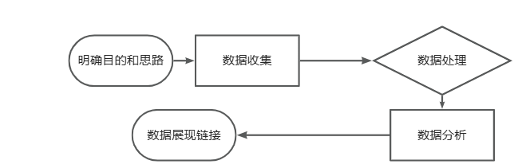

**Part 2:**

**Please watch the video again and summarize what you learn from the video, and discuss what is data analysis in your opinion.**

**Part 3:**

**Research on the internet to investigate commonly used data analysis tools, software, packages, etc. Select at least 3 data analysis tools of your choice and summary their advantages and disadvantages in a table.**

Example:

|  |  |  |  |  |
| --- | --- | --- | --- | --- |
| No. | Tool | Pros | Cons | Comments |
| 1. | A | 1. XXX 2. XXX | 1. XXX | XXXXX |
| 2. | B | 1. XXX | 1. XXX 2. XXX 3. XXX | XXXXXX |
| 3. | C | … | … | … |
| 4. | … |  |  |  |